

**SKILL JOURNAL**

Enrollment Number – 2019BTCS088 Year of Enrollment – 2019-2023

Name of the Student – YASH GUPTA

School of COMPUTER SCIENCE & INFORMATION TECHNOLOGY

Program – B. TECH

Specialization/ Branch – CS&IT

Semester – 3RD Section – B2 Branch – CS&IT

Paper Code – IDSC 202 Name of Paper – Personal Enhancement Skills I (Employability Skills)

Faculty-In-Charge – DR. CHARUL JAIN MAM

CERTIFICATE

THE SKILL EXPERIMENTS

ENTERED IN THIS JOURNAL HAVE BEEN SATISFACTORY PERFORMED BY

ENROLLMENT NO - 2019BTCS088 MR.­­­­­­­­­­­­­­­­­ YASH GUPTA

STUDYING IN PROGRAM B. TECH BRANCH CS&IT IN

SCHOOL OF COMPUTER SCIENCE & INFORMATION TECHNOLOGY

DURING SEMESTER 3RD OF ACADEMIC YEAR 2020-2021

_______________________

( )

Date: _________________

INDEX

|  |  |  |  |  |
| --- | --- | --- | --- | --- |
| S.NO | Title of Skill Activity | Date of Allocation | Date of Submission | Sign of Faculty |
| 1 | Resume Writing | April 21th, 2021 | April 24th, 2021 |  |
|  |  |  |  |  |
|  |  |  |  |  |
|  |  |  |  |  |
|  |  |  |  |  |
|  |  |  |  |  |
|  |  |  |  |  |
|  |  |  |  |  |
|  |  |  |  |  |
|  |  |  |  |  |
|  |  |  |  |  |
|  |  |  |  |  |
|  |  |  |  |  |
|  |  |  |  |  |
|  |  |  |  |  |
|  |  |  |  |  |
|  |  |  |  |  |
|  |  |  |  |  |
|  |  |  |  |  |
|  |  |  |  |  |
|  |  |  |  |  |
|  |  |  |  |  |
|  |  |  |  |  |
|  |  |  |  |  |
|  |  |  |  |  |
|  |  |  |  |  |
|  |  |  |  |  |
|  |  |  |  |  |
|  |  |  |  |  |
|  |  |  |  |  |
|  |  |  |  |  |
|  |  |  |  |  |
|  |  |  |  |  |
|  |  |  |  |  |
|  |  |  |  |  |
|  |  |  |  |  |
|  |  |  |  |  |
|  |  |  |  |  |
|  |  |  |  |  |
|  |  |  |  |  |
|  |  |  |  |  |
|  |  |  |  |  |

SKILL ACTIVITIY NO: 1

(Resume Writing)

Date: April 21st, 2021

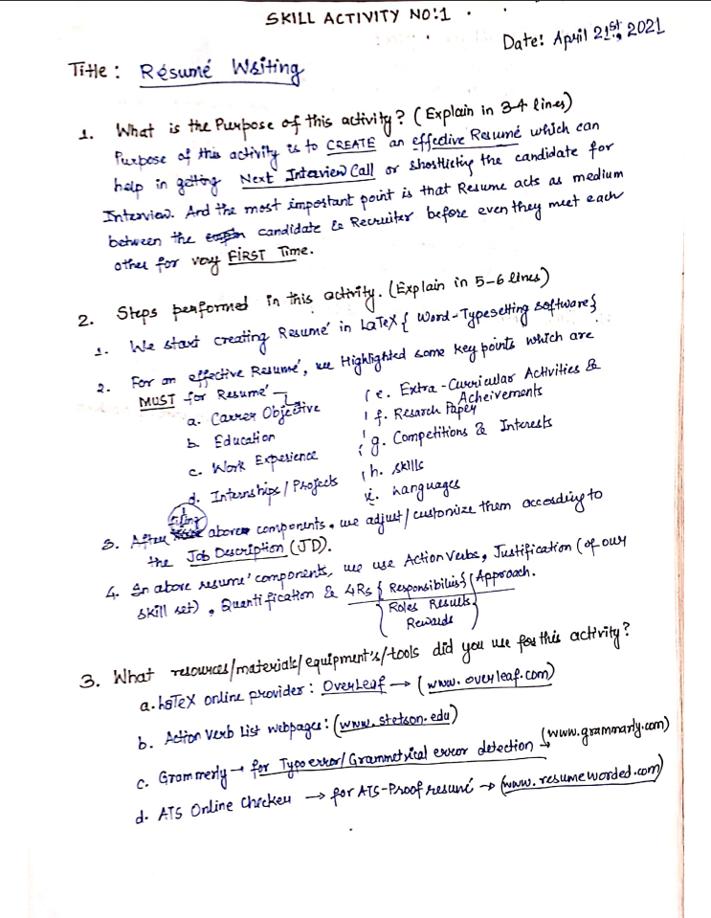

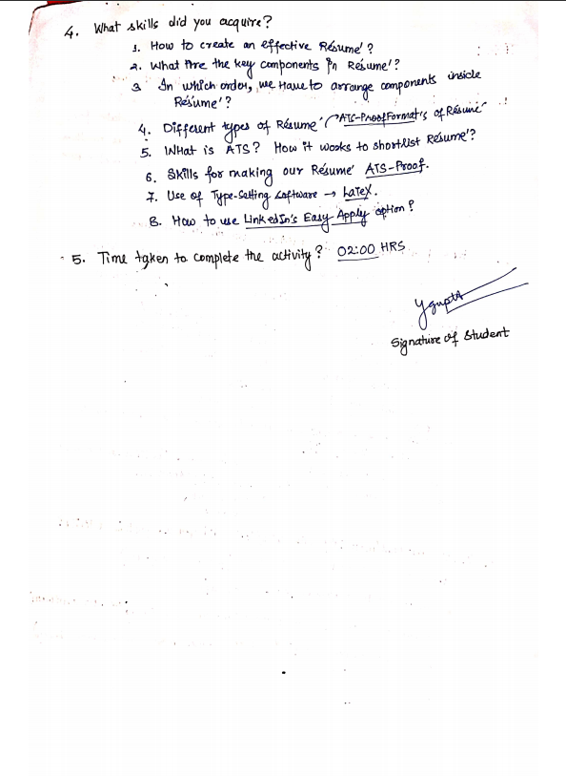  
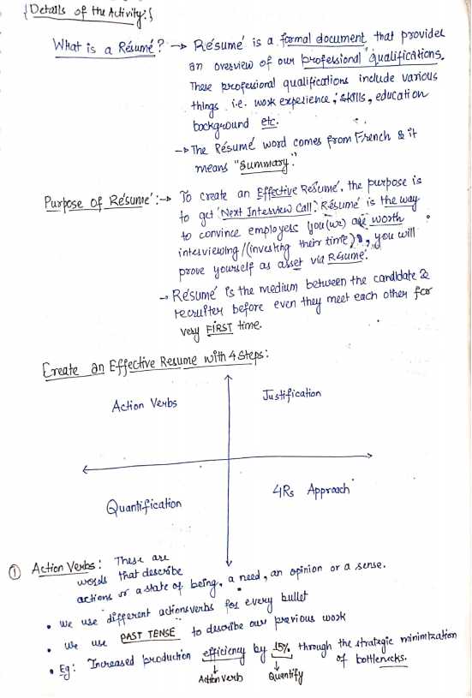

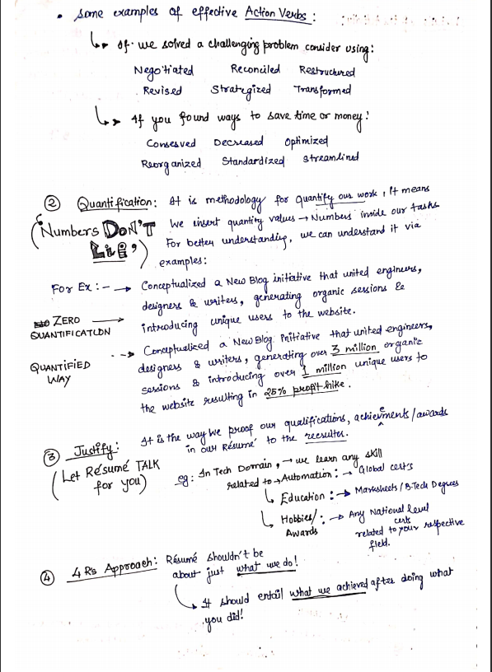

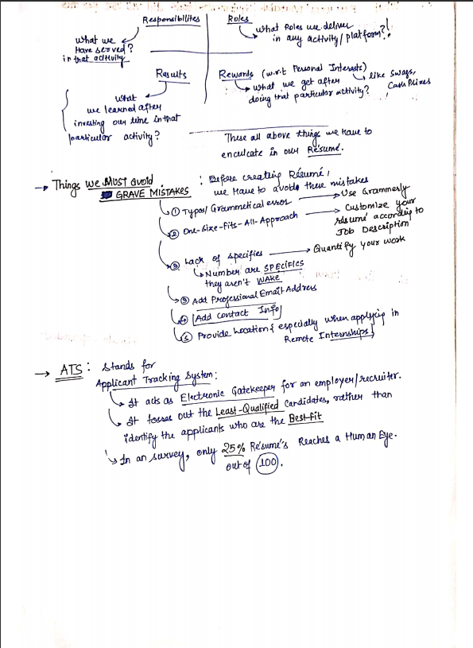

**(To be filled by Faculty)**

|  |  |  |
| --- | --- | --- |
| Sr. No. | Skill /Competencies | (Achieved / Not Achieved)  (Yes / No) |
| 1 | Resume Writing | Yes |
| 2 | SWOT of Self | Yes |

Remarks :

Total mark ___________________________out of 10.

Signature of Faculty

Date: _________________

**Details of the Activity**

